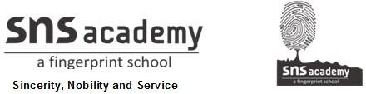

Grade : 6 Worksheet 1 Date:

Subject: Science.
- Match the Column I with Column II

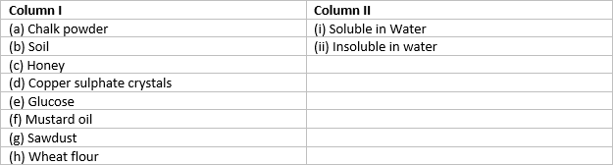

- Fill in the blanks
  - Materials that do not allow light to pass through them are called . 2.Metals have a shiny appearance called _ .
- Materials which can be pressed easily are called _ materials.
- Copper and gold are _
- __ _ and _ _ gas dissolves in water.

- State whether the statements given below are True or False. 1.Wood is transparent, while glass is opaque.
- Materials are grouped for convenience and to study their properties and their uses
- Hydrogen dissolves in water.
- A piece of wood floats on water.
- Oil mixes with water.

Answer the following.
- Why metals often lose their shine and appear dull?
- Which of the following materials is not lustrous?
(a) Gold. (b) Silver. (c) Wood
(d) Diamond
- How do aquatic plants and animals survive in water? 4.Which of the following is a soft material?
(a) Iron. (b) Sponge. (c) Plastic
(d) None of these

- Select odd one out?
(a) Aluminium. (b) Iron. (c) Silver
(d) Sand
- Find the odd one out from the following
(a) Tawa. (b) Spade. (c) Pressure cooker
(d) Eraser
- Which ones are correct
- A stone is hard. It therefore sinks in water.
- Sponge is soft. It can be compressed easily.
- Water in transparent. Things can be clearly seen through it.
- All are correct.
- Which one is compressible?
(A). Cotton. (B). Gold. (C). Marble (D). stone
- Which pair of substance float in water?
- Pin, oil drops
- Coin, rubber band
- Plastic ball, feather
- Iron nail, cotton thread
- You are provided with the following materials
(i) Magnifying glass (ii) Mirror
(iii) Stainless steel plate (iv) Glass tumbler
Which of the above materials will you identify as transparent?
- (i) and (ii)
- (i) and (iii)
- (i) and (iv)
- (iii) and (iv)

- Find the Jumbled word
- LLEOSBU
- LSEURT
- PRENNTARAST
- OHRUG
- GAVNIER
- TCASLPI

Crossword Puzzle

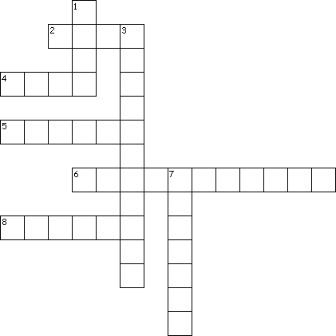
Across
2. cotton is a _ _materials
- The materials which are difficult to compress are known as
- Iron,copper , aluminium is called
- The materials through which objects can be seen, but not clearly, are known as
_
8. shiny appearance is termed as Down
1. Opaque material which we got from trees
3. water is a _ liquid
7. vinegar is in water

